PGI Intraop

Installation Guide

*Organization : Infosys*

*Version : 1.7.0*

*Created By : Rohit_sharma41*

Please follow below mentioned steps to install PGI Intraop application:

1) Click on setup file and a setup window popup.

2) Select directory where you wish to install the setup.

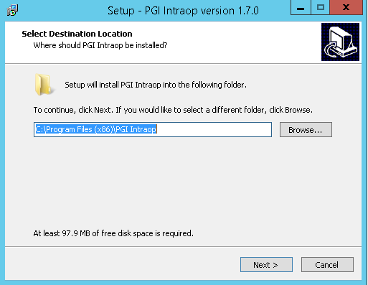

3) Make sure ***Create a desktop shortcut*** option is checked and click Next.

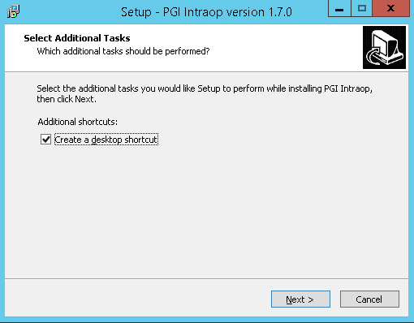

4) Click Install.

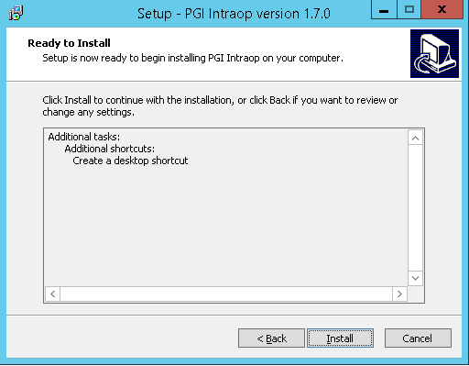

5) Installation process will start and create a copy at the specified setup location.

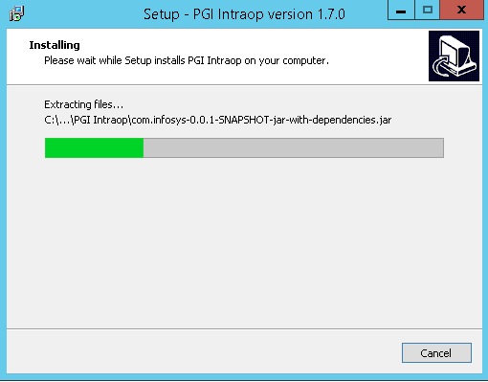

6) Check ***Launch*** option if you wish to start the application after finishing the installation.

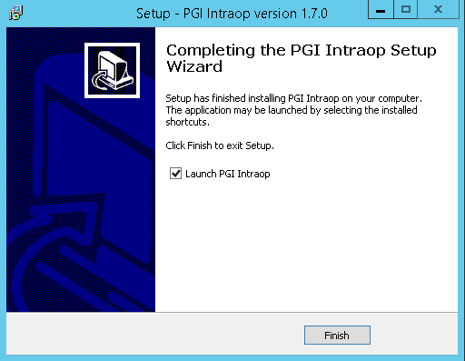

7) A shortcut named "PGI Intraop" is created on the desktop.